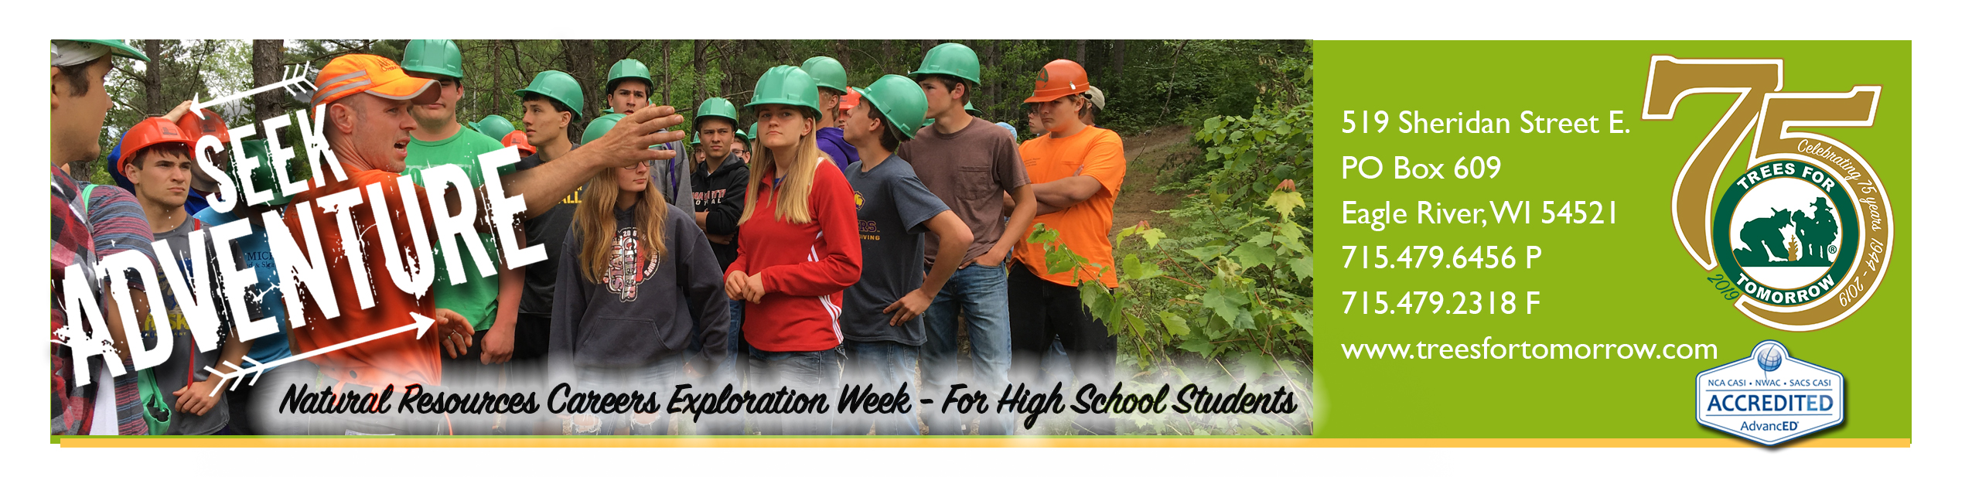

March 12, 2019
For immediate release: NOTE application deadline Friday, April 12, 2019
Contact: Vern Gentele, 715.479.6456 ext. 235 or vern@treesfortomorrow.com

TREES FOR TOMORROW HOSTS NATURAL RESOURCES CAREERS EXPLORATION WEEK FOR HIGH SCHOOL STUDENTS

EAGLE RIVER, Wis. – Trees For Tomorrow, an accredited natural resources specialty school in Eagle River, WI is accepting applications from high school students interested in attending Natural Resources Careers Exploration Week (NRCEW).

The 2019 workshop, set for June 16-21, at Trees For Tomorrow’s campus, will introduce students to foresters, fisheries and wildlife biologists, water resource specialists, conservation wardens, recreation land managers, and other natural resources professionals.

This workshop is a cooperative effort between Trees For Tomorrow, natural resource agencies, and corporate sponsors including Domtar-Nekoosa, Cellcom, and the Wisconsin County Forests Association. Scholarship donations from these partners make it possible for us to offer this program for only $200/student, which includes five days of valuable instruction, lodging and 15 homemade meals. Financial assistance may be available for students whose family has a demonstrated need. Participation is limited to 30, and students must complete the application materials and be recommended for the program by a teacher or school counselor to be accepted. Applications can be found on the Trees For Tomorrow website and are due by April 12th.

“We want to make this opportunity affordable for all high school students. The experience helps to point the next generation toward careers managing our valuable natural resources,” said Vern Gentele, coordinator of NRCEW.

“Thanks to our corporate partners, we can provide this program for a minimal fee, and provide additional assistance to those who may need extra help in participating in this life-changing experience,” he said. “This program helps students quickly gauge what interests them, what the various occupations require for education or training, what they pay, and what today's job market is like.”

Trees For Tomorrow has sponsored this high school workshop for more than 50 years. Sophomores, juniors and graduating seniors are eligible to attend.

Information and application materials are available at www.treesfortomorrow.com/H-S-Careers-Week/ or by calling Vern Gentele at (715) 479-6456.

###

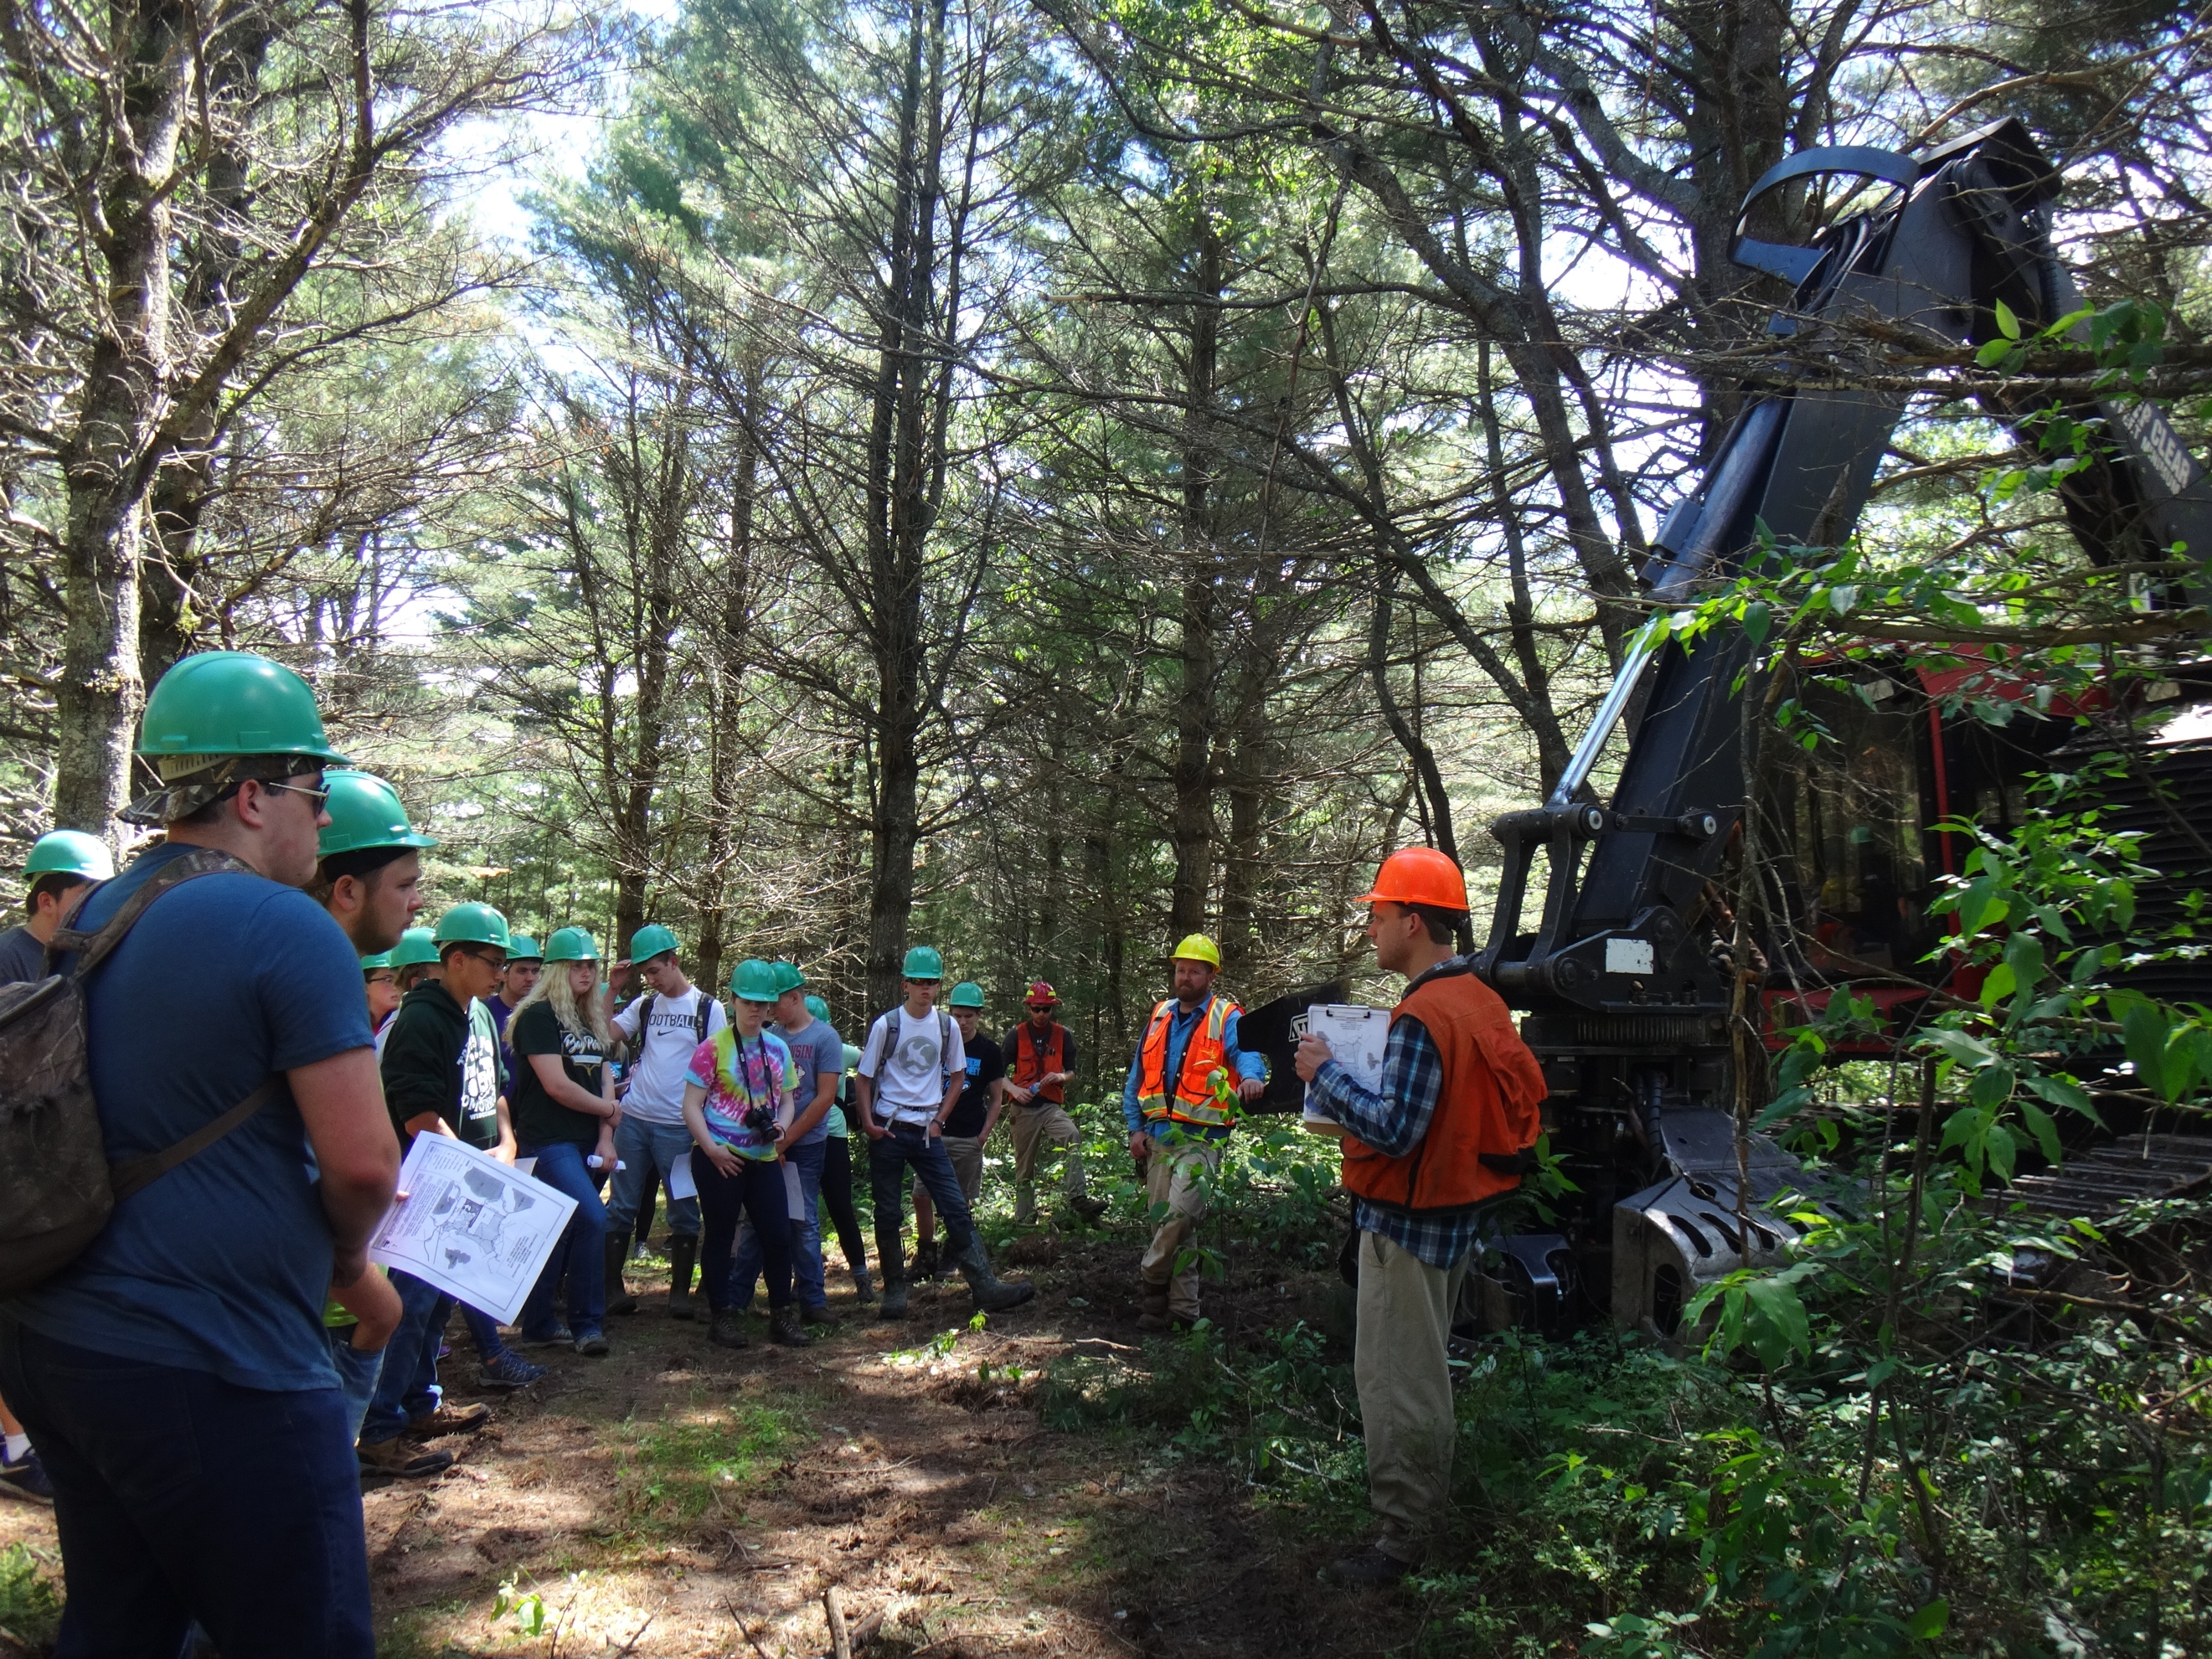

Photo caption 1:

Students gain a better understanding while working directly with natural resource specialists in the field.

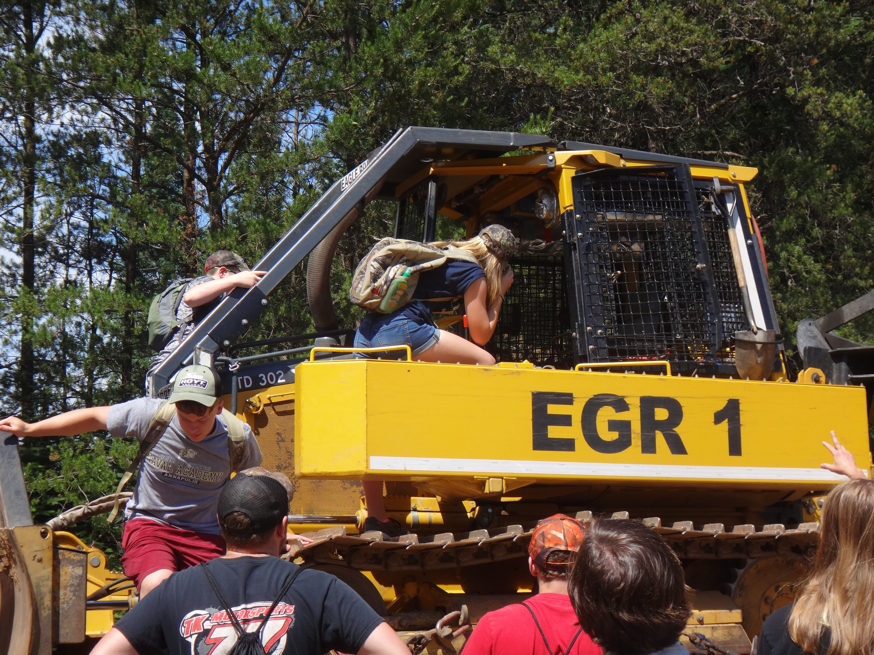

Photo caption 2: Students get up close and personal with forestry equipment.

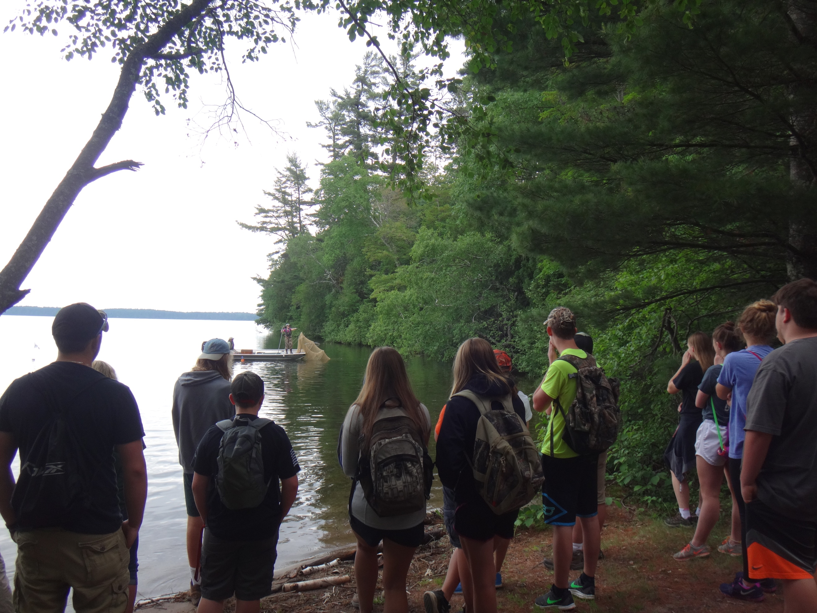

Photo caption 3: Students experience real-life field work including developing applicable outdoor skills.

